**DBMS Project Questions And Queries**

**DDL with Constraints**

**Q1.Create a table login with columns id as primary key, username as not null , password and privilege.**

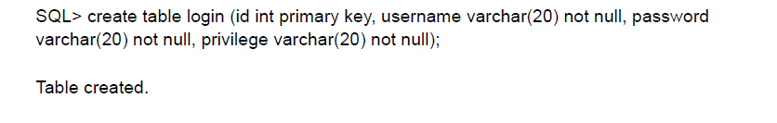

**Q2.Create a table book_details with id from login as forein key , author ,title etc as columns.**

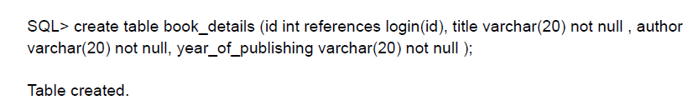

**Q3.Alter table book details and change column title capacity from 20 to 50 .**

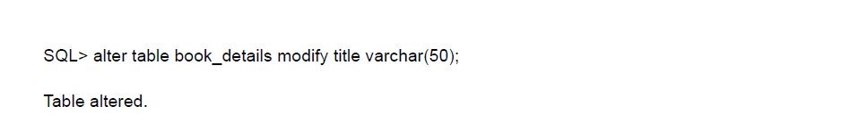

**Q4.Delete table book_details .**

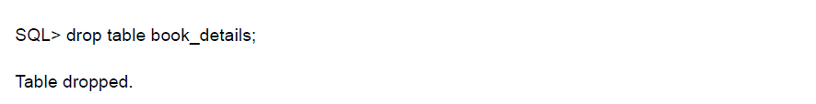

**Q5.Again create a table book_details with id from login as forein key ,bookid as primary key, author ,title etc as columns .**

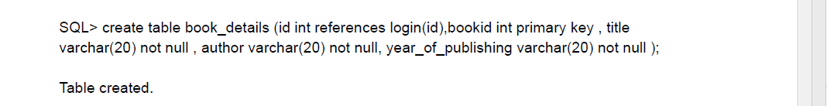

**DML and Functions**

**Q1.Select all the results form table login which have privileges as Admin from table login .**

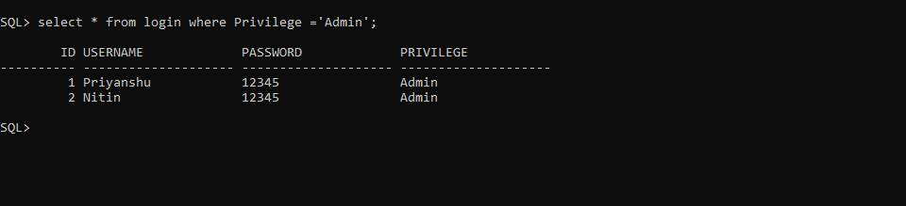

**Q2.Select all the results from table book_price where issue price is equal to 100 rupees .**

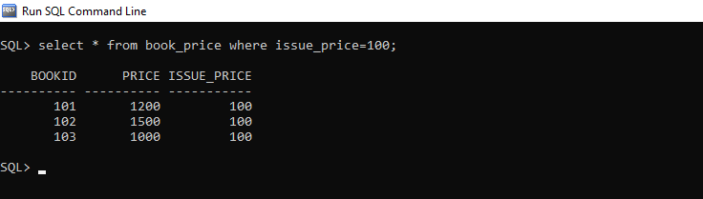

**Q3.Select only Author name from table book details where bookid is 104 and title is Let us C++.**

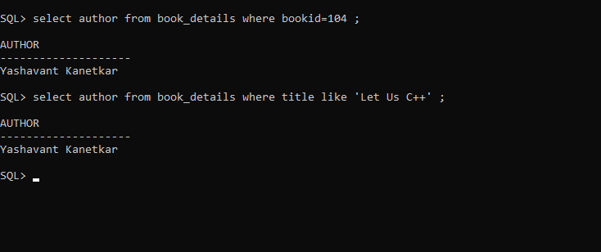

**Q4.Select user names from table login where name starts from letter ‘S’ .**

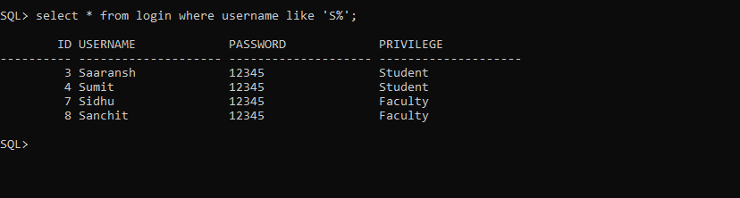

**Q5.Select all usernames in lower case letters from table login.**

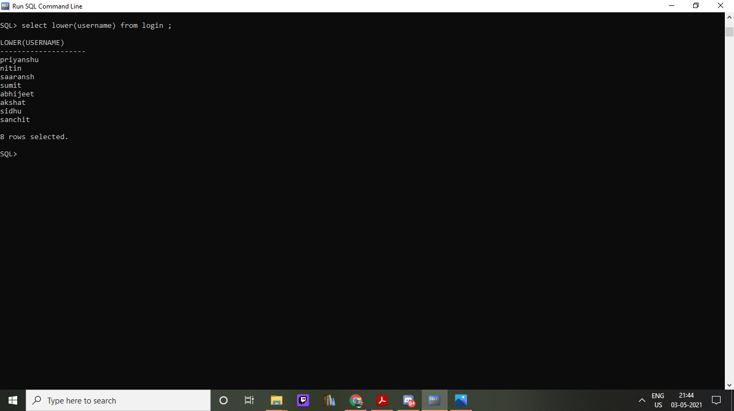

**Q6.Select all usernames with first letter capital from table login.**

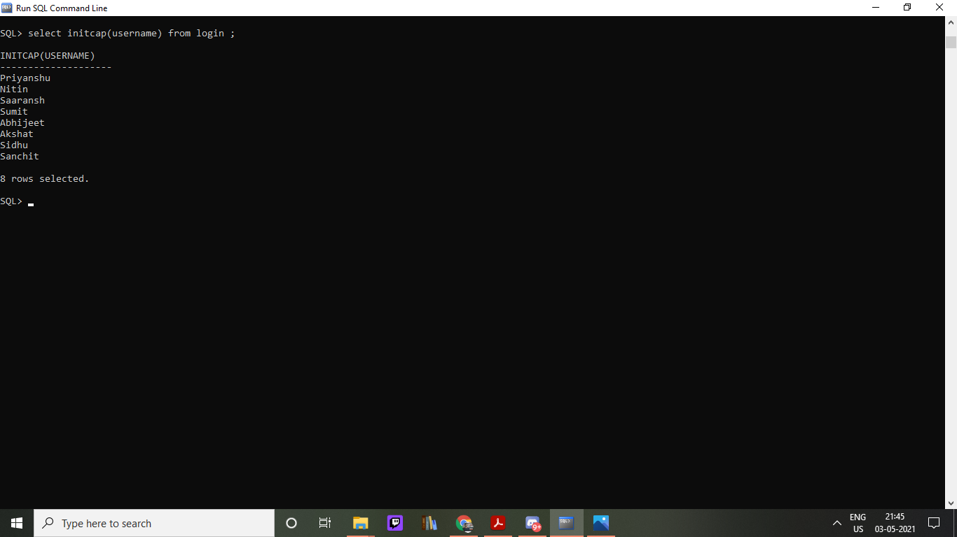

**SET Operations**

**Q1. Show id and bookid combined for table book_details and book_isssue and also delete duplicates.(Union)**

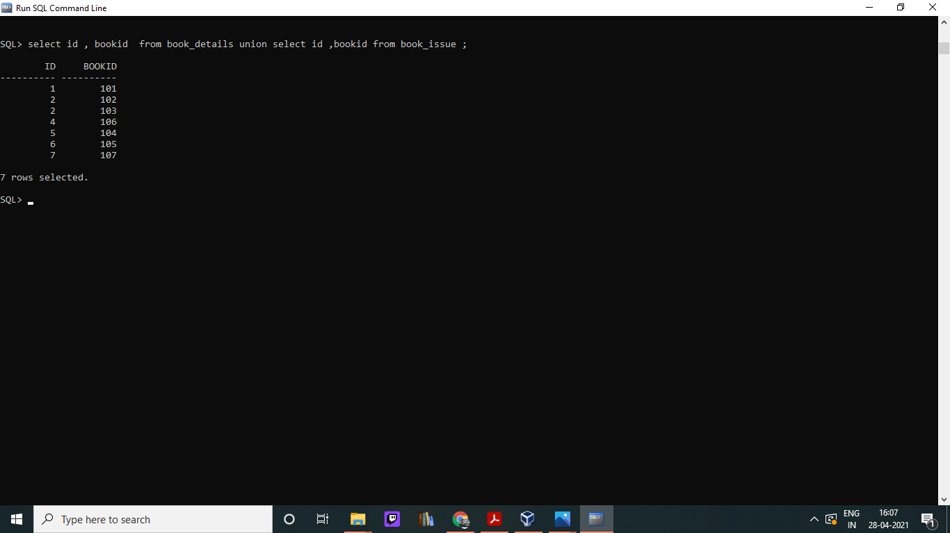

**Q2. Show id and bookid combined for table book_details and book_isssue without deleting duplicates.(Union ALL)**

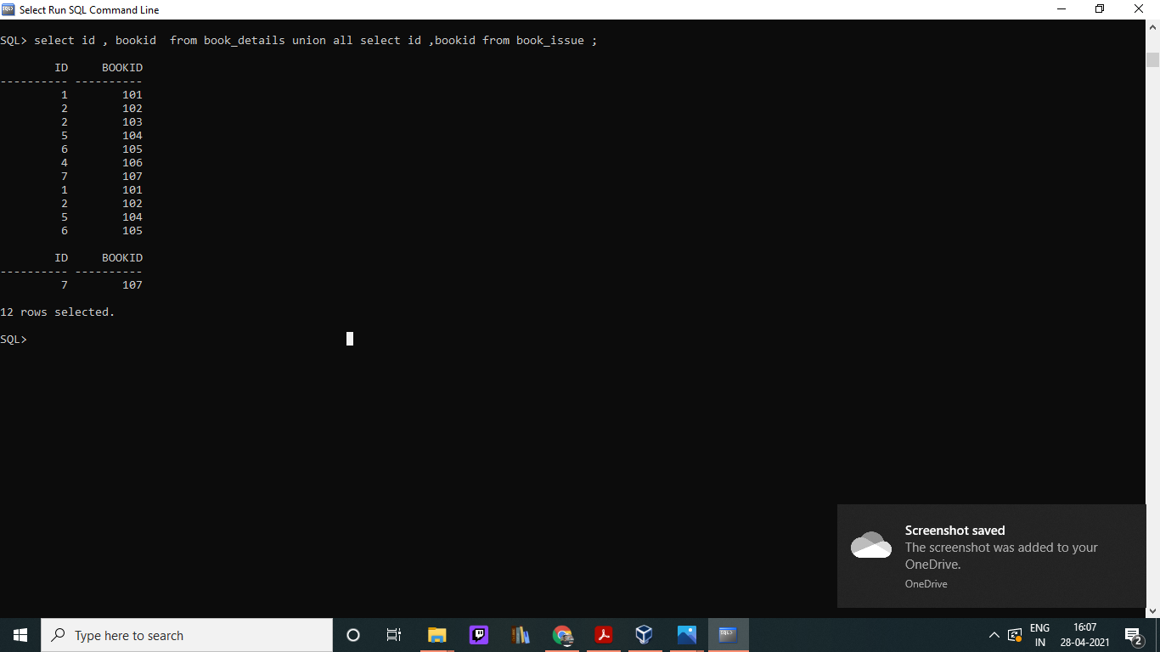

**Q3. Show id and bookid for table book_details minus book_issue.**

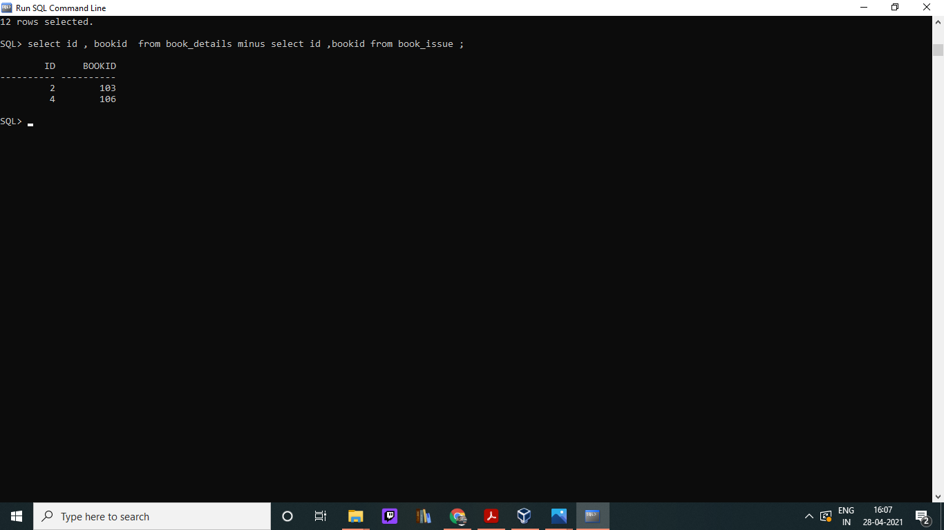

**Q4. Q1. Show id and bookid intersecting for table book_details and book_isssue .**

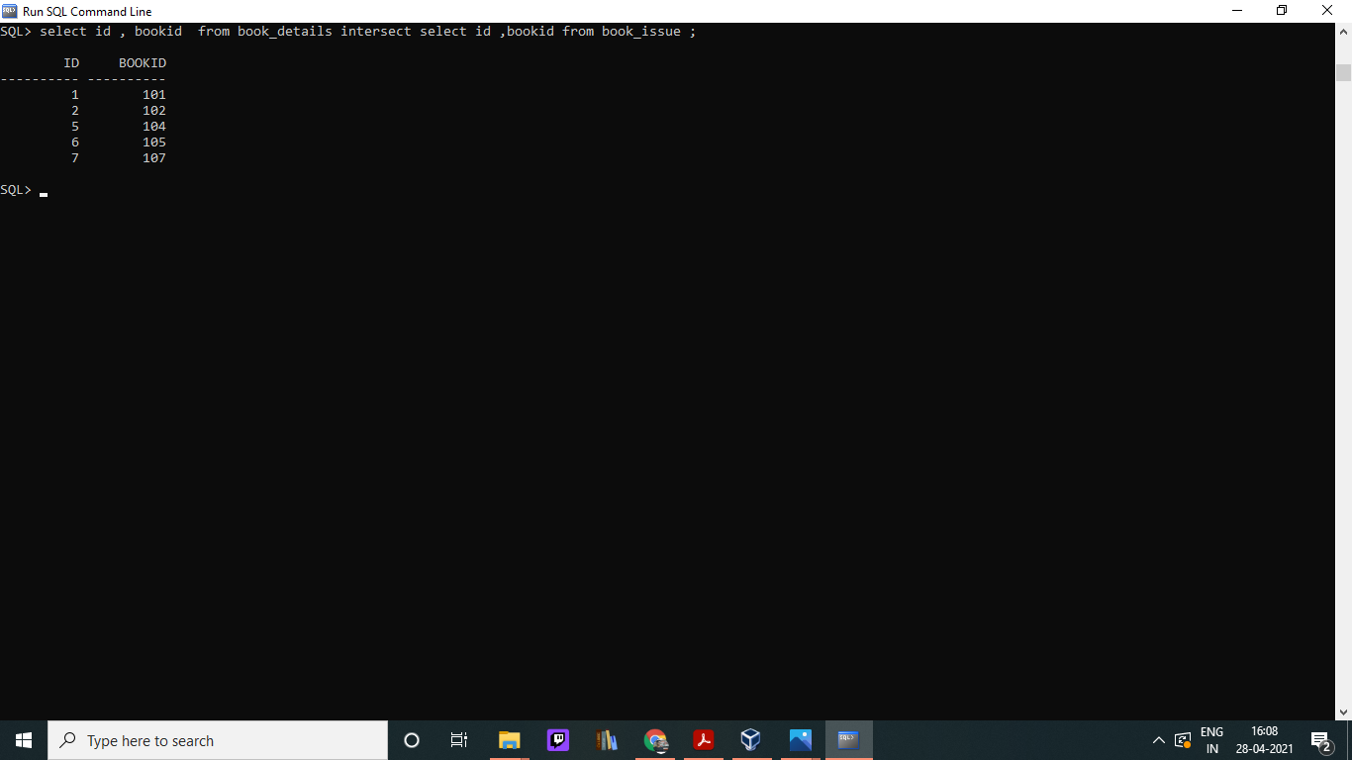

**Aggregation**

**Q1.Select the most costly and least costly book from table book price and also show the sum of all prices .**

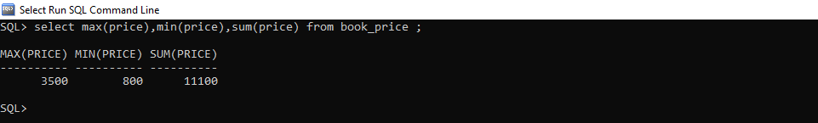

**Q2. Select the average price of books from table book price .**

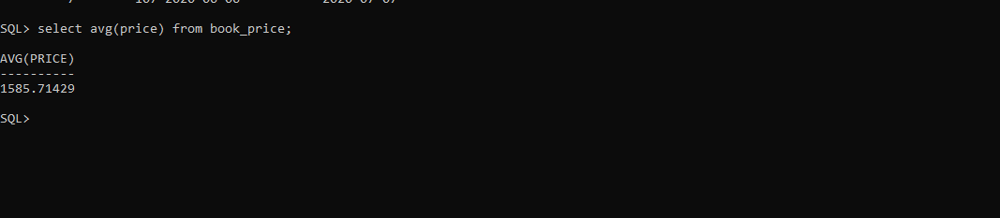

**Q3. Count all the books present in the library .**

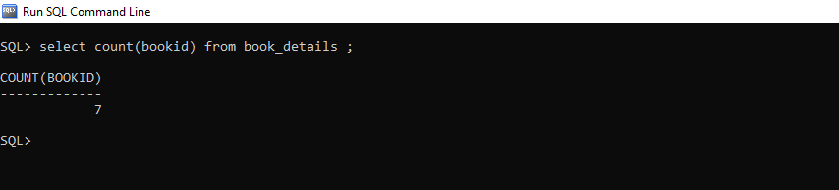

**Q4. Calculate sum off prices of all books in the library.**

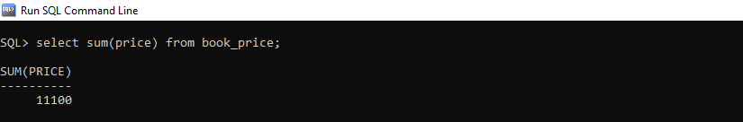

**Q5. Select minimum issue price for a book.**



**Joins**

**Q1.Select usernames,id,title from tables login and book details which belong to both tables (Inner Join).**

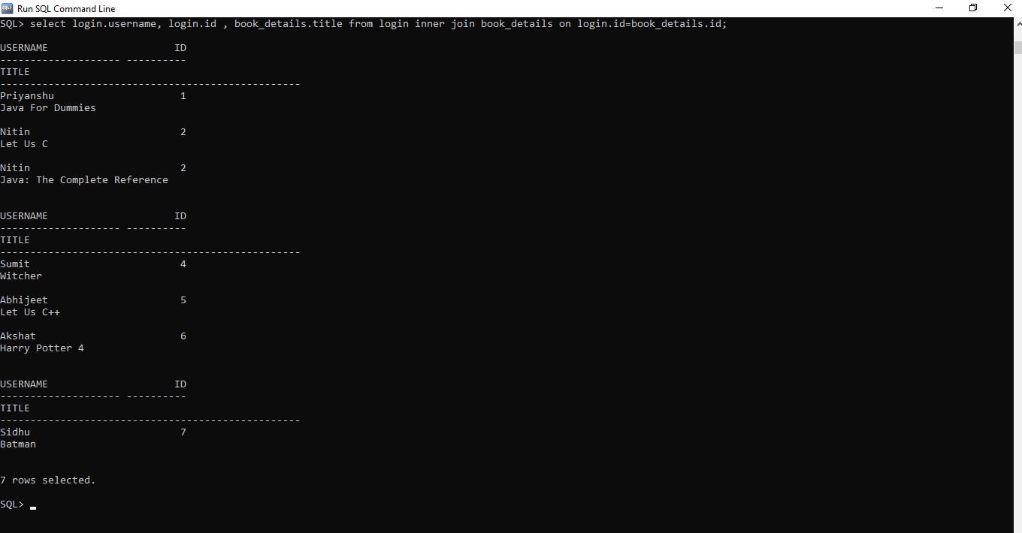

**Q2.Select usernames,id,title from tables login and book details but show only data which is in the login table and is also related to the book details table (Left Join).**

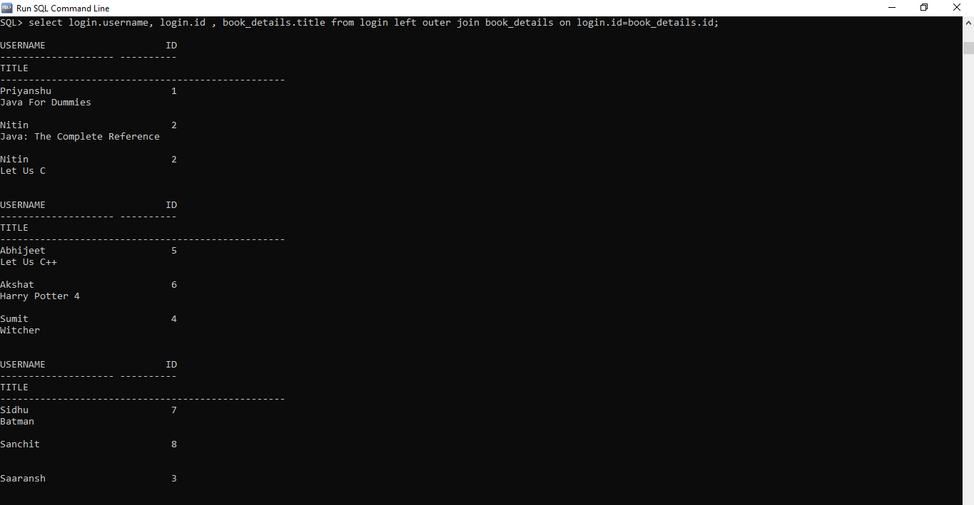

**Q3. Select all data of usernames,id,title from tables login and book details (Full Join).**

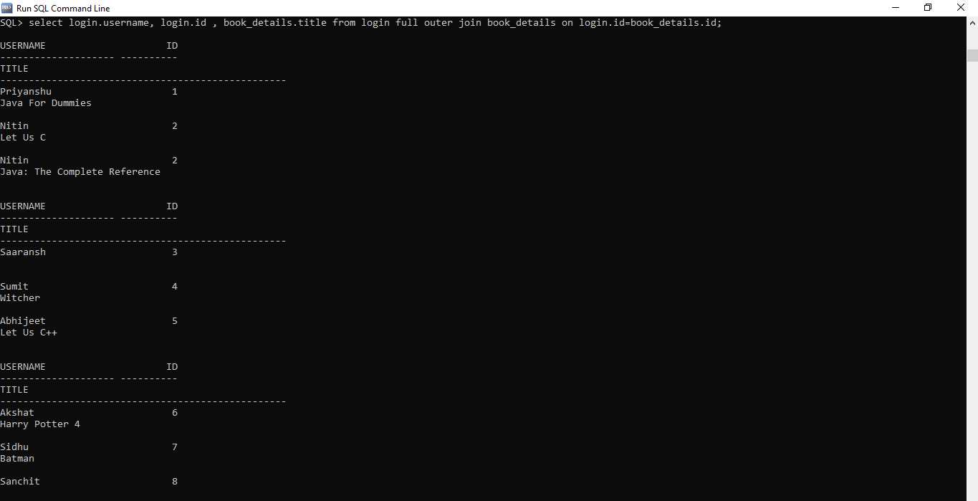

**Q4.Select id,bookid,issue date, author and title data from tables book_issue and book_details in which above mentioned data belongs to issue table and is also related to other table (Left Join)**

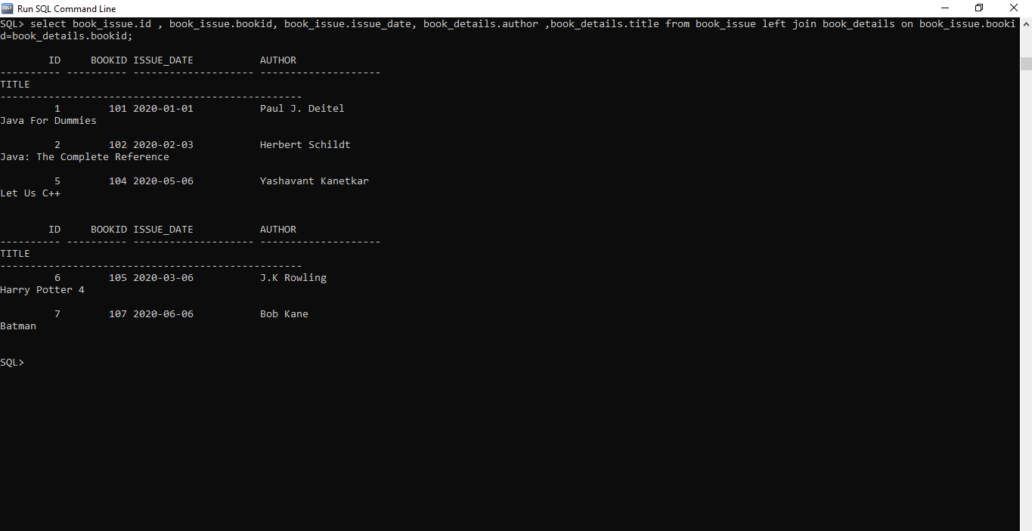

**Q5.Select all data of id,bookid,issue date, author and title data from tables book_issue and book_details (Full Join)**

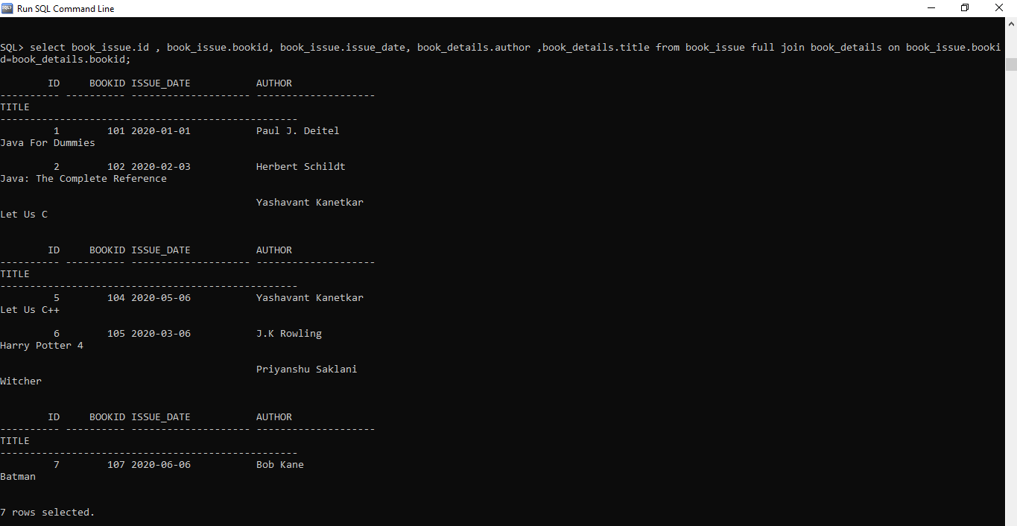

**Sub Queries**